Project Documentation

Project Title : STORE MANAGER KEEP TRACK IN INVENTORY

# Introduction

## Project Title: STORE MANAGER KEEP TRACK IN INVENTORY

* + **Team ID :** **NM2025TMID47718**
  + **Team leader &ID : S.PRABA** [**&prabasankar199@gamil.com**](mailto:&prabasankar199@gamil.com)
  + Team Member :
  + S. POOVIZHI & [spoovizhi8107@gmail.com](mailto:spoovizhi8107@gmail.com)
  + N. PRAVESHIKA [&npraveshika2007@gmail.com](mailto:&npraveshika2007@gmail.com)
  + S.RAMYA SRI & [ramyasrineet23@gmail.com](mailto:ramyasrineet23@gmail.com)

# Project Overview

* + - **Purpose:** In a **Store Manager (Inventory Management System)**, the **purpose** is to help a store (retail, wholesale, or warehouse) run smoothly by keeping track of goods, stock levels, and sales.

FEATURES :

**1.Inventory Management System** A system to track, update, and manage inventory items across client and server.

### 🖥️ Client Setup

bash

cd client

npm install

This installs all necessary dependencies for the frontend (React, Vue, etc.).

### 🗄️ Server Setup

bash

cd ../server

npm install

This installs backend dependencies (Express, Mongoose, etc.).

If you want, I can help you add more setup steps like running the server, connecting to a database, or even writing a README file. Just let me know what tech stack you're using (Node.js, MongoDB, etc.) and what you'd like to include.

# Folder Structure

Code

SB-Works/

├── client/ # React frontend

│ ├── components/ # Reusable UI components

│ └── pages/ # Page-level components (e.g., Home, Dashboard)

│

└── server/ # Node.js backend

├── routes/ # API route definitions

├── models/ # Mongoose/ORM models for DB schema

└── controllers/ # Logic for handling requests

**🛠️ Suggestions for Expansion**

If you're planning to scale this project, consider adding:

* client/assets/ for images, fonts, and styles
* server/middleware/ for auth, logging, error handling
* server/config/ for environment variables and DB setup
* README.md at the root for setup instructions and documentation.

# Running the Application

## 🖥️ Frontend (React)

## bash

## cd client

## npm start

## Starts the React development server.

## Default port: http://localhost:3000

## 🗄️ Backend (Node.js)

## bash

## cd server

## npm start

## Launches the Node.js server (Express or similar).

## Make sure your backend is configured to run on a different port (e.g., 5000) to avoid conflicts with the frontend.

## 🌐 Access the App

## Open your browser and visit: http://localhost:3000 This loads the frontend, which communicates with the backend via API calls.

## If you’re using environment variables or a proxy setup in package.json, I can help you configure that too. Want to add login, database, or deployment steps next?

1. **Access:**

## User:

* + - /api/user/register
    - /api/user/login

## Projects:

* **Provide Store Managers with Centralized Access**: Offer a single platform where store managers can access all critical business data, including sales, inventory, staffing schedules, and more.
* **Enhance Efficiency**: Streamline processes such as order management, sales tracking, and customer service, improving overall operational efficiency.
* **Improve Decision Making**: Provide insights and reports that allow managers to make data-driven decisions about inventory, staffing, promotions, and more.
  + **Chats:**
* /api/projects/create
* /api/projects/:id • **Applications:** /api/apply
* /api/chat/send
* /api/chat/:userId

# Authentication

**JWT-Based Authentication**

**JSON Web Tokens (JWT)** are a compact, URL-safe way of representing claims between two parties. They're commonly used for authentication in web apps.

* **Login Flow**:
  + User submits credentials (e.g., email and password).
  + Server verifies credentials and generates a JWT.
  + JWT is sent back to the client and stored (usually in localStorage or a cookie).
  + For subsequent requests, the client includes the JWT in the Authorization header.
* **Token Structure**:
  + **Header**: Specifies the signing algorithm (e.g., HS256).
  + **Payload**: Contains user data and claims (e.g., user ID, role).
  + **Signature**: Ensures the token hasn’t been tampered with.
* **Security Tips**:
  + Use HTTPS to prevent token interception.
  + Set token expiration (exp) to limit session duration.
  + Consider using refresh tokens for long-lived sessions.

**🛡️ Middleware for Route Protection**

Middleware acts as a gatekeeper for your routes, verifying the JWT before allowing access.

* **How It Works**:
  + Middleware intercepts incoming requests to protected routes.
  + It checks for the presence and validity of the JWT.
  + If valid, it allows the request to proceed.
  + If invalid or missing, it returns an error (e.g., 401 Unauthorized).
* **Example (Node.js/Express)**:

js

const jwt = require('jsonwebtoken');

function authenticateToken(req, res, next) {

const token = req.headers['authorization']?.split(' ')[1];

if (!token) return res.sendStatus(401);

jwt.verify(token, process.env.JWT_SECRET, (err, user) => {

if (err) return res.sendStatus(403);

req.user = user;

next();

});

}

// Usage

app.get('/private', authenticateToken, (req, res) => {

res.send('This is a protected route');

});

# User Interface

**1. Landing Page**

**Purpose:** First impression, marketing, and user conversion **Key Features:**

* Eye-catching hero section with a clear value proposition
* Call-to-action buttons (e.g., “Join as Freelancer” / “Post a Project”)
* Testimonials or success stories
* Overview of platform features
* Navigation to login/signup

**🧑‍💻 2. Freelancer Dashboard**

**Purpose:** Workspace for freelancers to manage their profile and projects **Key Features:**

* Profile overview and edit options
* Active, pending, and completed projects
* Messaging center for client communication
* Earnings and withdrawal section
* Notifications and alerts

**🛠️ 3. Admin Panel**

**Purpose:** Control center for platform management **Key Features:**

* User management (freelancers and clients)
* Project moderation and approval
* Financial tracking and analytics
* Reports and insights dashboard
* Settings for platform rules, fees, and content

**📄 4. Project Details Page**

**Purpose:** Showcase individual project info and facilitate bidding or collaboration **Key Features:**

* Project title, description, budget, and deadline
* Client profile and rating
* Proposal submission form
* Comments or Q&A section
* Tags or categories for filtering

# Testing

* Conducted **manual testing** at key development milestones to ensure feature stability and performance
* Utilized tools such as **Postman** for API validation and **Chrome DevTools** for front-end debugging and performance analysis

If you're compiling this for a resume or portfolio, I can help tailor it even further based on your role (QA, developer, etc.) or the project context. Want to expand this into a full section or keep refining other points?

# Existing solutions

* Git hub link [ <https://github.com/prabasankar199-png/Inventory.git>]

1. **Screenshots or Demo** 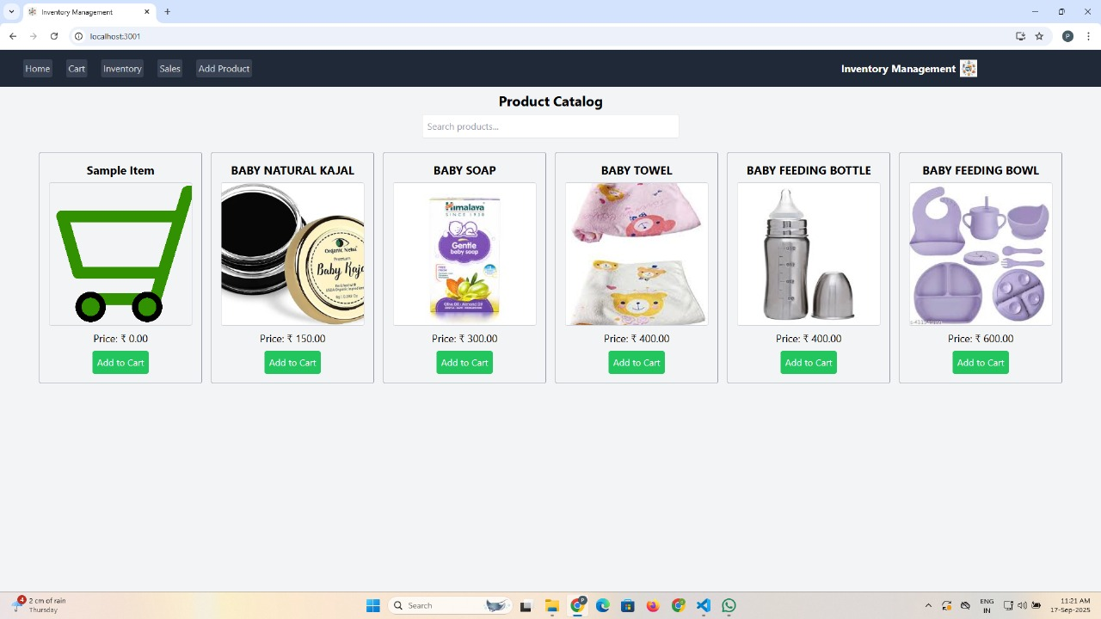 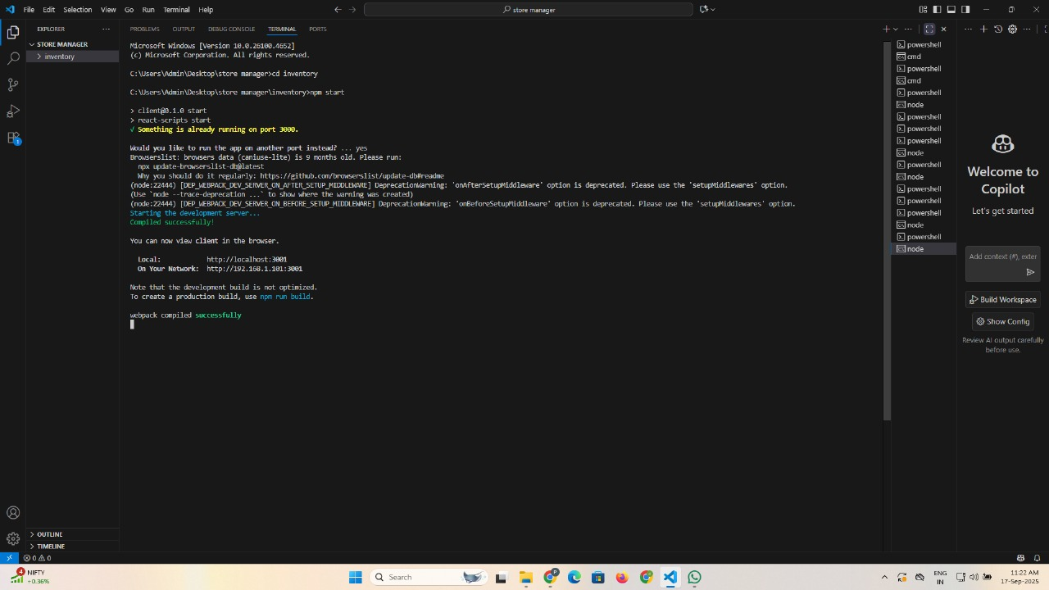
2. **Known Issues** **🖥️ Software or app issues (e.g., bugs in a program or system)?**

**📄 Project documentation (like a section in a report or release notes)?**

**🏗️ Product development (issues in a prototype or rollout)?**

**🌐 Website or platform problems?**

**If you're drafting a “Known Issues” sec**

1. **Future Enhancements**

**1. Performance Improvements**

* **Optimize system speed and responsiveness**
* **Reduce latency or load times**
* **Enhance scalability for larger user bases**

**2. Feature Expansion**

* **Introduce new functionalities based on user feedback**
* **Integrate with third-party tools or platforms**
* **Add multilingual support or accessibility features**

**3. User Experience (UX) Upgrades**

* **Refine interface design for better usability**
* **Implement personalization or adaptive UI**
* **Improve onboarding and help systems**

**4. Security & Compliance**

* **Strengthen data encryption and privacy protocols**
* **Ensure compliance with evolving regulations**
* **Add multi-factor authentication or biometric access**

**5. AI & Automation**

* **Use machine learning for predictive analytics**
* **Automate routine tasks or workflows**
* **Introduce smart assistants or chatbots**

**6. Analytics & Reporting**

* **Expand dashboard capabilities**
* **Enable real-time data visualization**
* **Add customizable reporting tools**